Project Design Phase-II
Data Flow Diagram & User Stories

Date | 22 October 2026
Team ID | [Enter Team ID]
Project Name | Electric Vehicle Market Performance & Insights
Maximum Marks | 4 Marks

Data Flow Diagrams:
A Data Flow Diagram (DFD) is a traditional visual representation of the information flows within a system. A neat and clear DFD can depict the right amount of the system requirement graphically. It shows how data enters and leaves the system, what changes the information, and where data is stored.
DFD Symbol Legend
Symbol | Name | Description
Oval / Rounded  shape | External Entity | A person, organization, or system outside the project that sends or receives data (e.g., Customer, Payment Gateway).
Rectangle with  numbered header | Process | An activity that transforms incoming data into outgoing data (e.g., Validate Request, Process Order).
Rectangle (solid fill, no number) | Data Store | A place where data is held for later use (e.g., Customer Database, Inventory).
Labeled arrow | Data Flow | The movement of data between entities, processes, and data stores, labeled with what data is being passed.

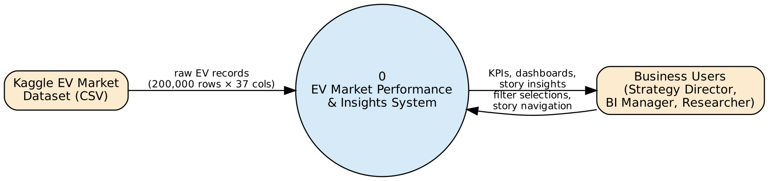
Figure 1: DFD Level 0 (Context Diagram) – EV Market Performance & Insights
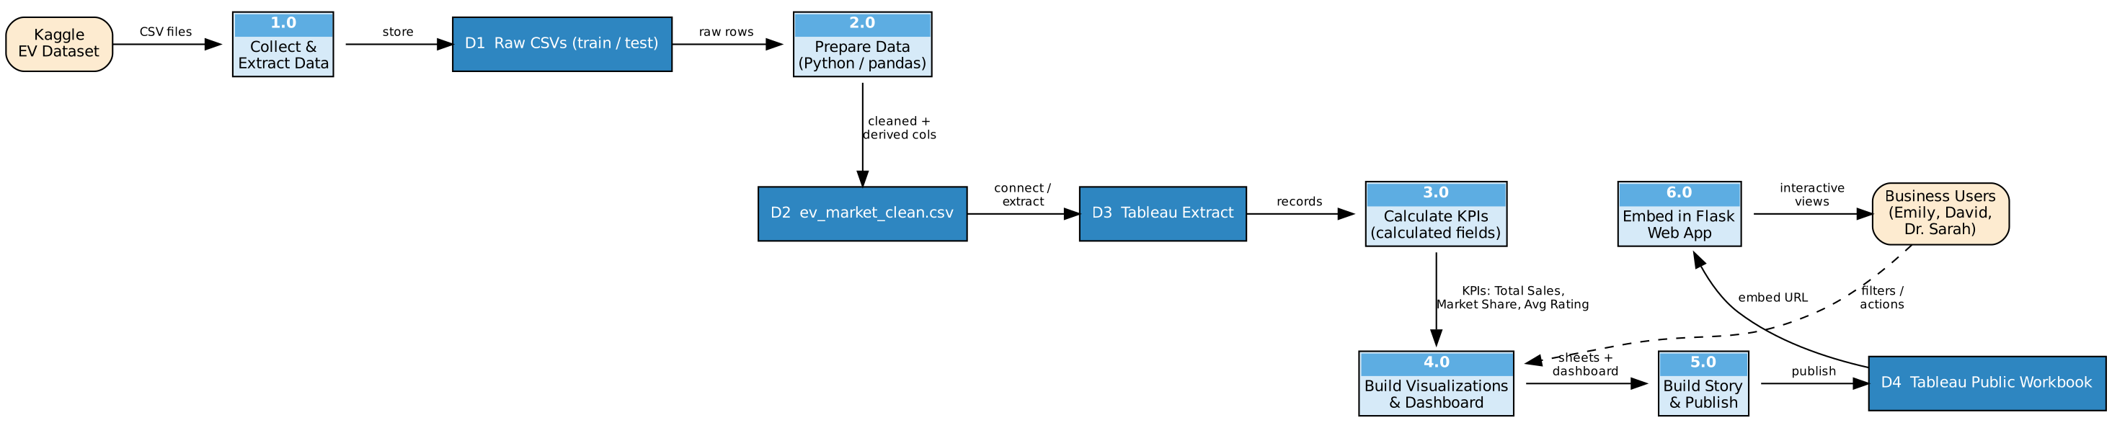
Figure 2: DFD Level 1 – processes 1.0–6.0 and data stores D1–D4

User Stories
Use the below template to list all the user stories for the product.
User Type | Functional Requirement (Epic) | User Story Number | User Story / Task | Acceptance criteria | Priority | Release
Market Strategy Director (Emily) | Data Collection & Extraction | USN-1 | As a user, I want the EV market data loaded into Tableau so that all categories, manufacturers and regions are available for analysis. | Data source shows 200,000 records and 37 fields with correct data types | High | Sprint-1
 | Data Preparation | USN-2 | As a user, I want missing and duplicate records handled so that KPIs are accurate. | 0 nulls and 0 duplicate vehicle_id in prepared data; imputed rows flagged | High | Sprint-1
 | Dashboard | USN-3 | As a user, I can see total annual sales, average rating and average range as KPI cards. | KPI Summary shows 1,550,703,961 units, 4.09 rating, 324.5 km | High | Sprint-2
 | Data Visualizations | USN-4 | As a user, I can see which vehicle categories contribute most to annual sales. | Sorted bar chart of annual sales by 15 categories | High | Sprint-2
BI Manager (David) | Data Visualizations | USN-5 | As a user, I can view the Top-10 manufacturers by market share. | Bar chart with market-share % labels for top 10 of 200 manufacturers | High | Sprint-2
 | Data Visualizations | USN-6 | As a user, I can see annual sales by manufacturing country on a map. | Filled map of 10 countries coloured by annual sales | Medium | Sprint-2
 | Dashboard | USN-7 | As a user, I can filter the dashboard by battery type and by % of total annual sales. | All sheets update when a filter or legend item is selected | High | Sprint-3
Research Analyst (Dr. Sarah) | Data Visualizations | USN-8 | As a user, I can compare battery-type share and total driving range by battery type. | Pie chart of battery share and bar chart of range by battery type | High | Sprint-2
 | Data Visualizations | USN-9 | As a user, I can compare customer ratings across categories and battery types. | Heatmap of avg customer rating (category × battery type) | Medium | Sprint-2
 | Story | USN-10 | As a user, I can walk through a story explaining the main insights. | Story with 5 captioned story points published | High | Sprint-3
All users (Web user) | Web Integration | USN-11 | As a web user, I can open the dashboard and story inside a web page. | Flask app embeds Tableau Public views (Home, Dashboard, Story, About) | Medium | Sprint-4
 | Performance Testing | USN-12 | As a user, I want views to load quickly. | Extract used; views render < 3 s; filters/calcs documented | Medium | Sprint-4
Administrator (Analyst) | Project Demonstration & Documentation | USN-13 | As the analyst, I can publish code, documentation and a demo video. | GitHub repo, Tableau Public link and documentation submitted | High | Sprint-4

